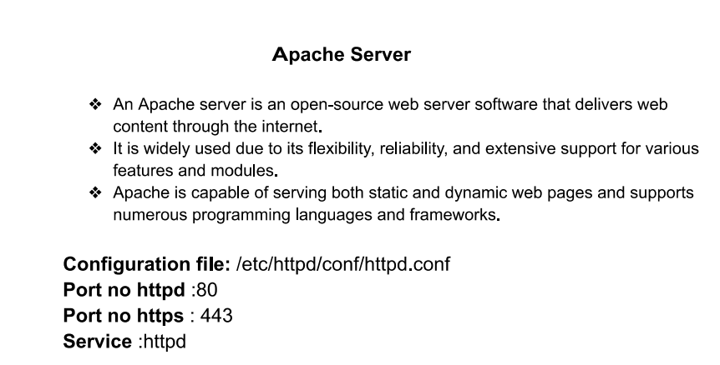

**There are two types of virtual hosting:**

* **Name Based virtual hosting**
* **IP Based virtual hosting**

Step 1

Install package

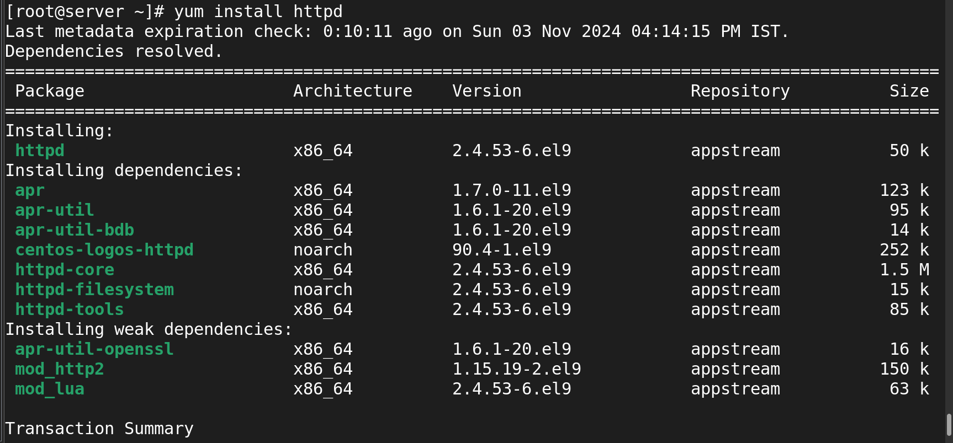

**Step-2:**

**Listing the package and search for vhost.conf for copying**

**rpm -qa |grep httpd**

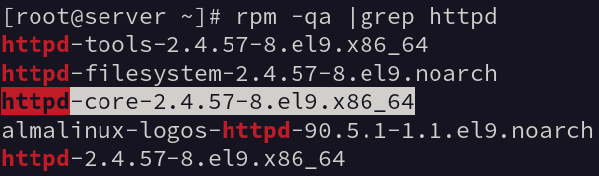

**rpm -ql httpd-core-2.4.57-8.el9.x86_64 |grep vhost**

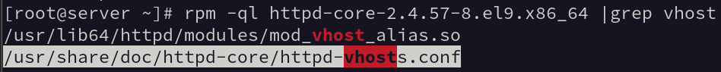

Now I go and viwe the above copyed path with vi

After viwe the config file I copy the below content

And paste in the my cofig file.

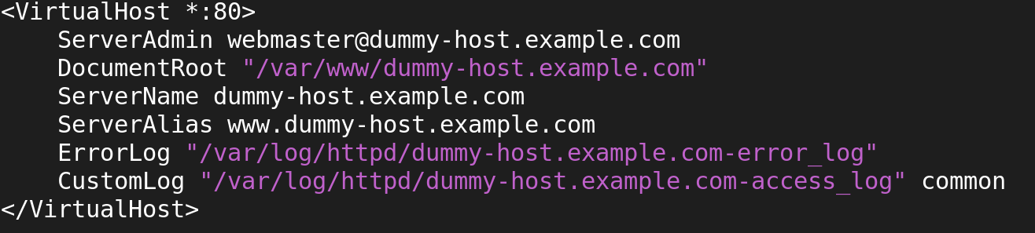

Step 4

Create own config

**Create a new config file namebased.conf**

**vi /etc/httpd/conf.d/namebased.conf**

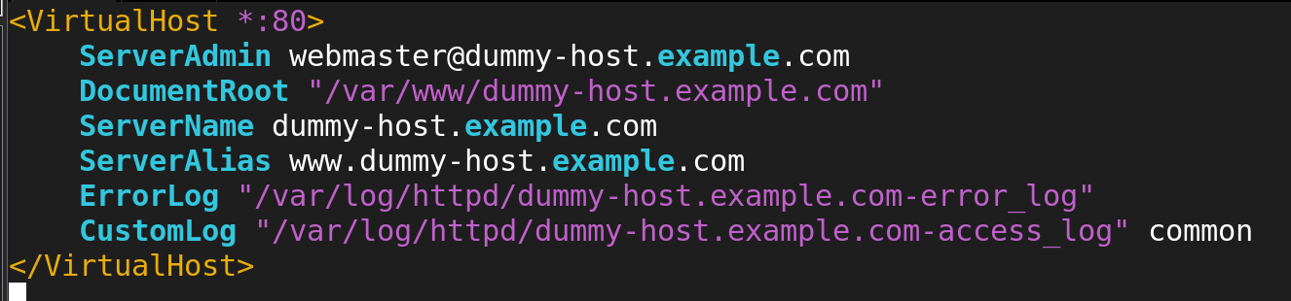

Next step to modify the small changes in the above confi

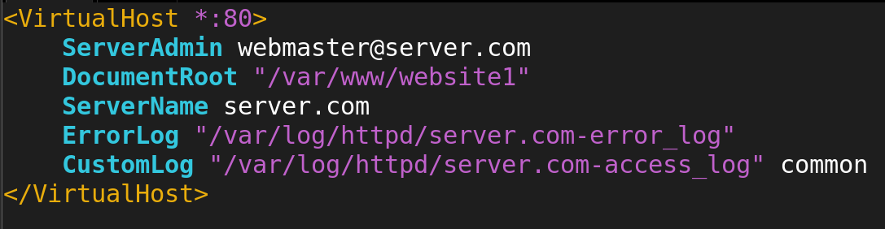

Now I am going to create my own dir in the path /var/www/(dir name)

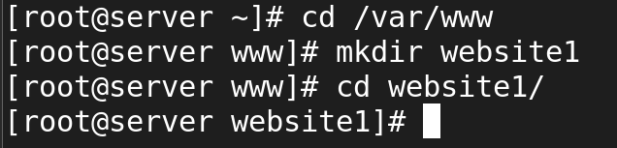

Now iam going to create an index.html file by using vi and in that file I am going to write some content.



Next step I was putting entry in the dns server.

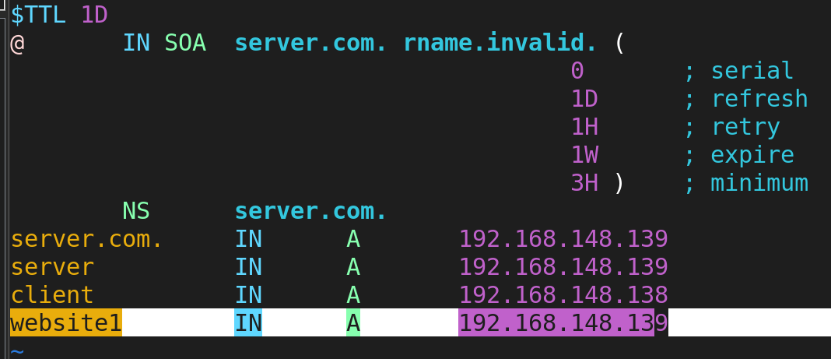

Now I am going to restart the both serveice and also enable the httpd service

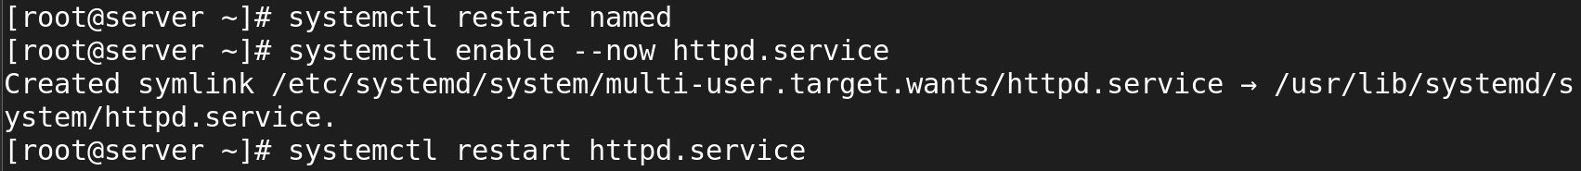

**Testing the website locally**

**curl [http://s](http://namebased.com)erver.com**

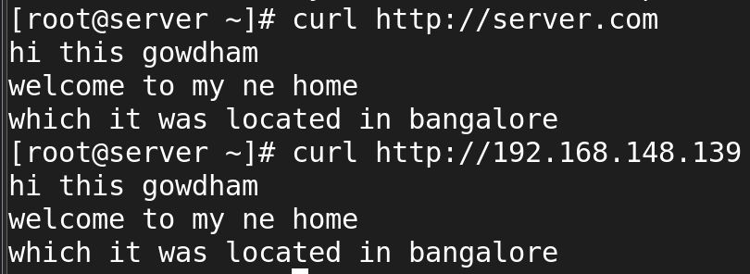

Now I am check through the firefox website

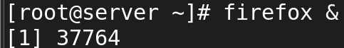

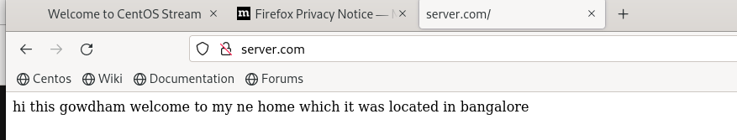

**IP-BASED Virtual Hosting**

The ip based dom ain also as same as the above steps

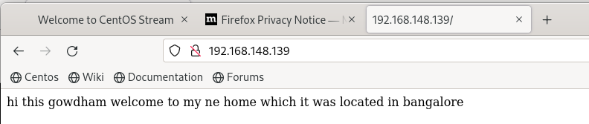

**Ssl**

Generating ssl certificate for https web server :

**Creating a self-signed certificate on CentOS 8 can be done using openssl, a powerful toolkit for the Transport Layer Security (TLS) and Secure Sockets Layer (SSL) protocols.**

**Configure SSL for your apache webserver:**

* **Install package: mod_ssl openssl**
* **Set up the certificate**
* **Configure apache to use SSL**
* **Adjust the firewalld**
* **Restart the apache service**
* **Test the configuration**
* **Save the changes and restart the apache**

**dnf install openssl**

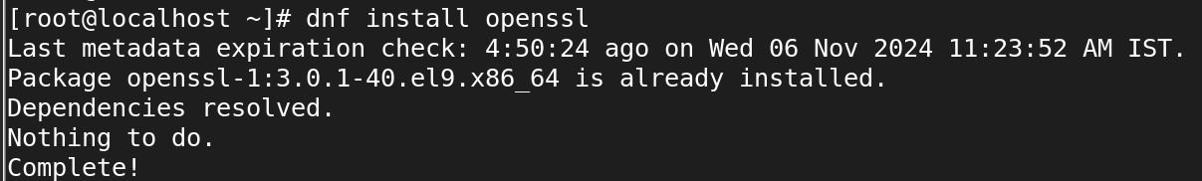

**Generating a private key**

**openssl genpkey -algorithm RSA -out my-private-key.key**

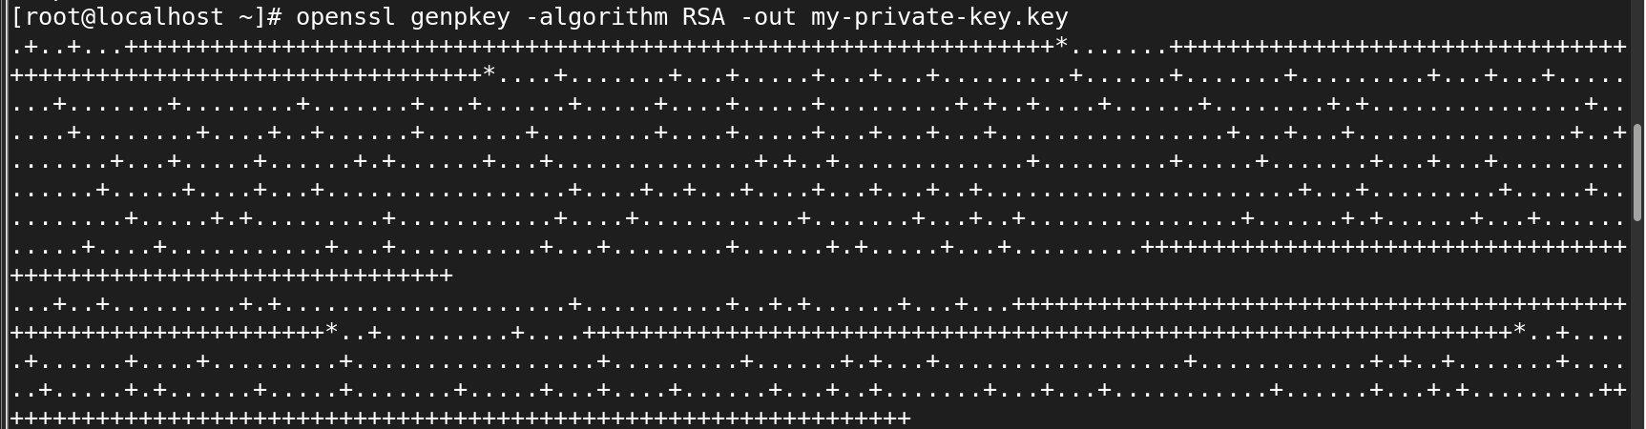

**Step-3: generating self signed certificate:**

**openssl req -new -x509 -key my-private-key.key -out my-certificate.crt -days 365**

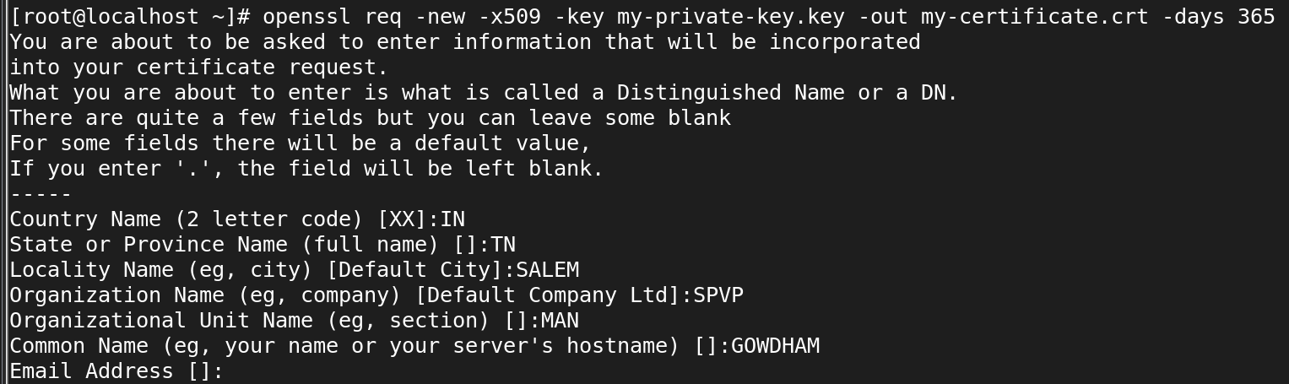

The private key will be created in home directory because you created keys in the home directory

**Step-4: changing permission for the private key**

**chmod 600 my-private-key.key**

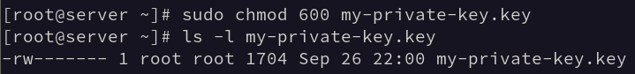

## ****Configure SSL for your apache webserver****

To configure SSL in Apache on CentOS 8, follow these steps:

Ensure that you have the mod_ssl and openssl packages installed. The mod_ssl module provides SSL v3 and TLS support for the Apache HTTP Server.

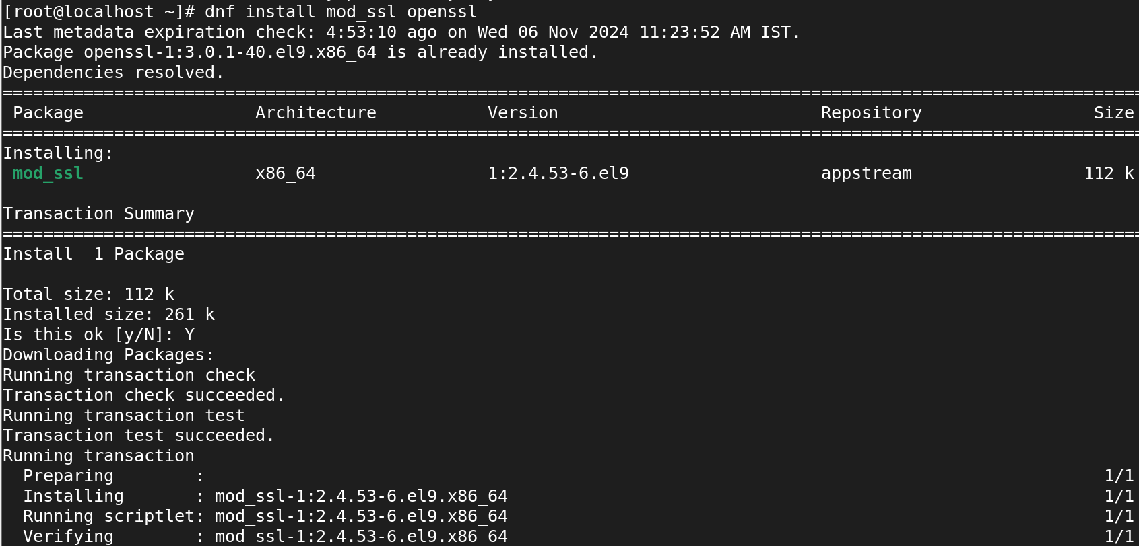

Now I move that I created **private key and certificate** in the root home to the path to **/etc/pki/tls/private and /etc/pki/tls/certs**

**mv my-private-key.key /etc/pki/tls/private/**

**mv my-certificate.crt /etc/pki/tls/certs/**



**Configuring the ssl config file  
 vi /etc/httpd/conf.d/ssl.conf**

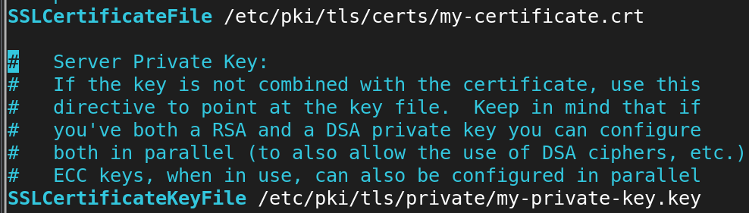

**Configuring the apache config**

**vi /etc/httpd/conf.d/nambased.conf**

**adding this following entries**

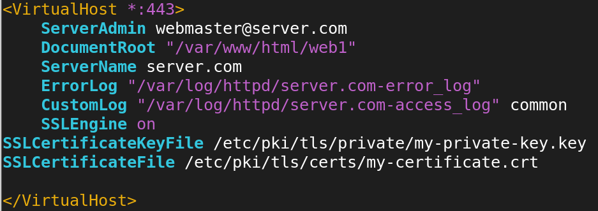

### . Adjust the Firewall:

If you're using firewalld, you need to allow HTTPS traffic through:

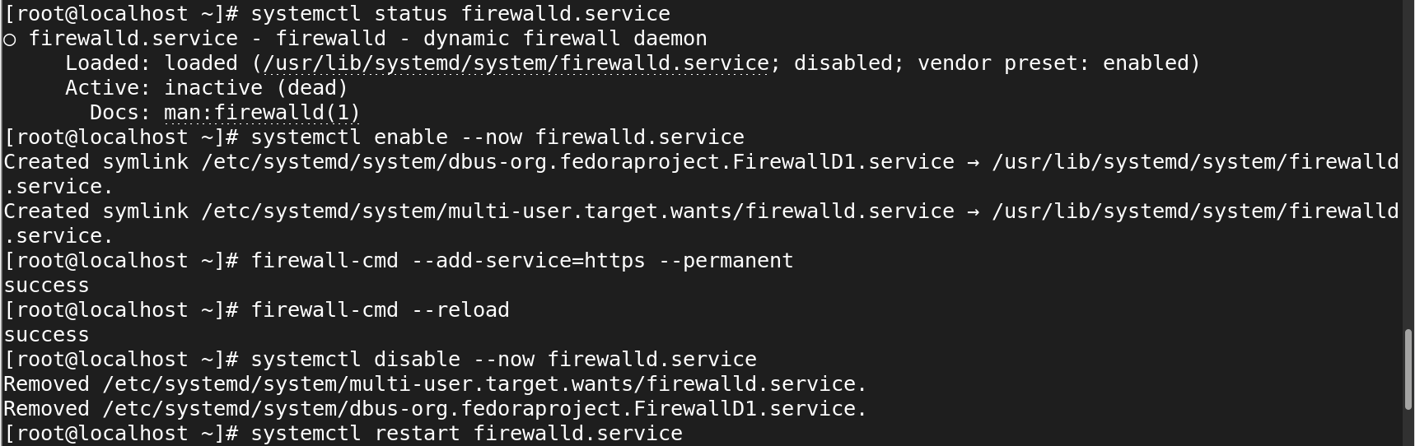

**Restarting the service apache**

**systemctl restart httpd**



**Testing the certificate in the browser:**